If you do not already have a video editor/converter, go to: http://www.squared5.com and download the converter for your system (In this document we are covering the Windows Version) 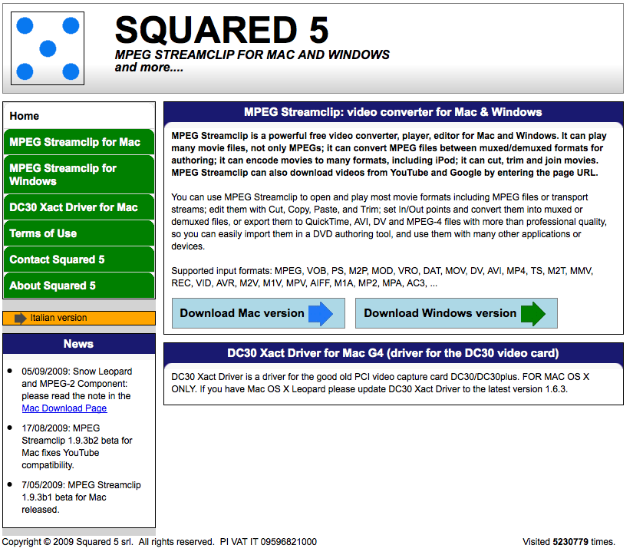

So you have your video and you have compression software. You’re ready to go!

- When MPEG Streamclip finishes downloading, you can Double-Click it from the Downloads Folder or find it in your specified download folder. 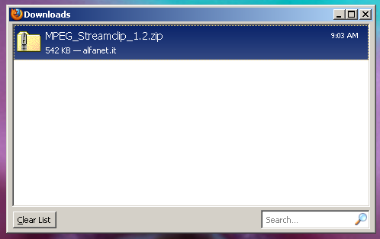

Either way, this is the next screen you will see. Double-Click MPEG Streamclip
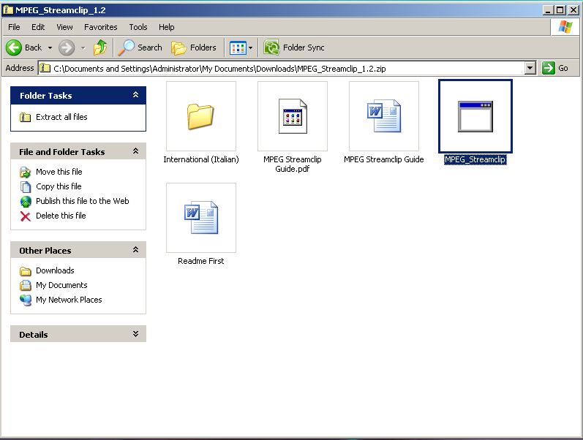

When the Compressed (zipped) Folders Warning Pops-up, choose Extract All and follow the directions in the Extraction Wizard
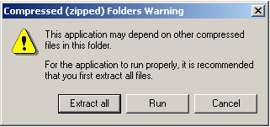

- Open MPEG_Streamclip
Note: the first time you open MPEG Streamclip you will get a pop-up asking you to agree to the license agreement.
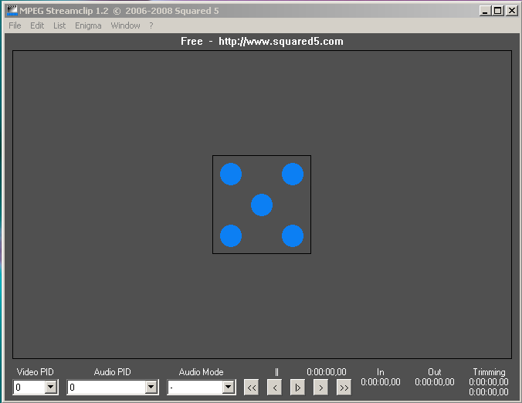

- Locate the video file you want to compress/convert
For example: mine is in a folder entitled “movies” within my documents
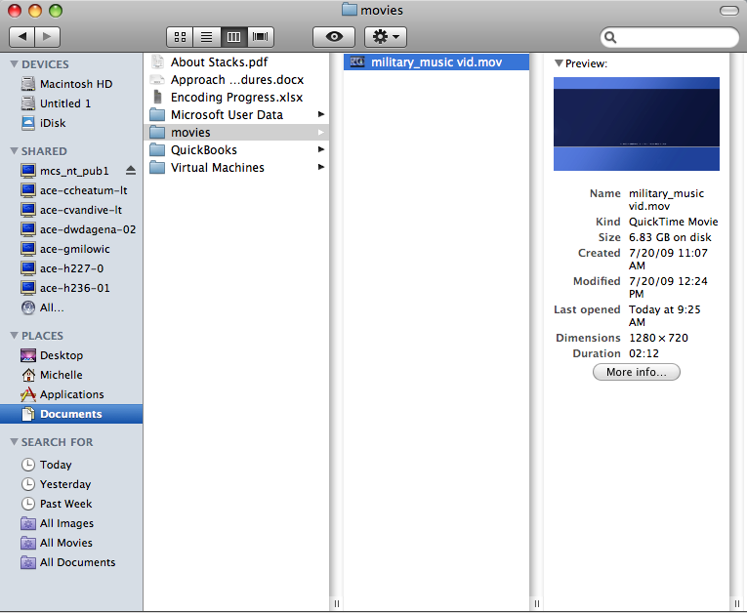
(as you can see, this movie is currently 6.83 GB, much too big for placement on Ensemble)

- Drag and Drop the video from its location into the MPEG Streamclip area (anywhere within the gray area is fine)
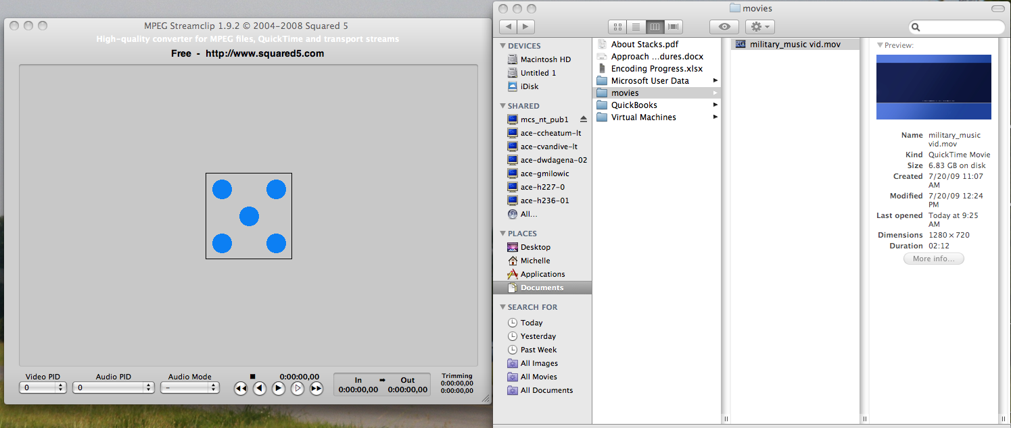

You will see the video in what use to be the gray area of MPEG Streamclip, and can scroll through it, or even trim it if you wanted by using the “In” and “Out” points.
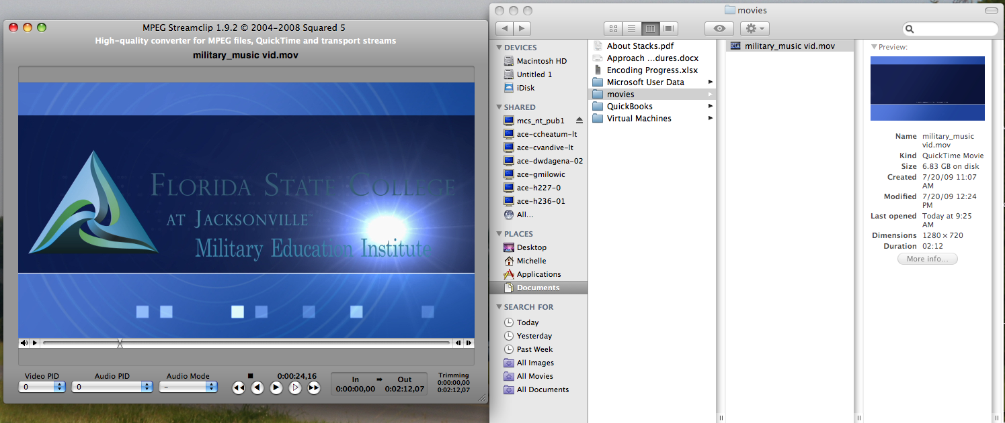

- Go to File in the Menu Bar and choose Export to MPEG-4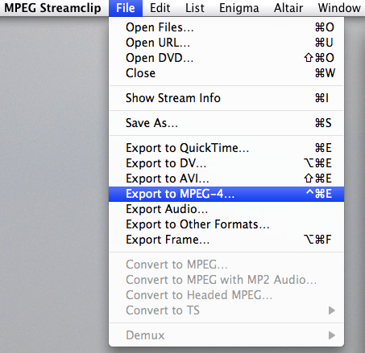

5a. Make sure you fill out the next Pop-up as detailed in the picture below:
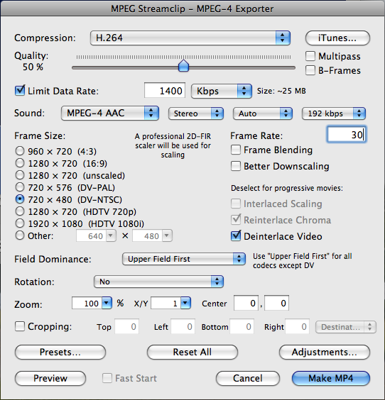
Then click on “Make MP4”
5b. Name your file and choose where you want it saved and choose “Save”
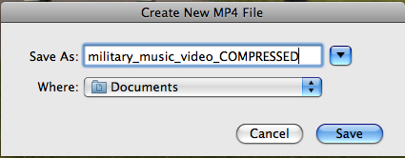

You will then see the Exporter Preview and Status Bar (seen in the pictures below)
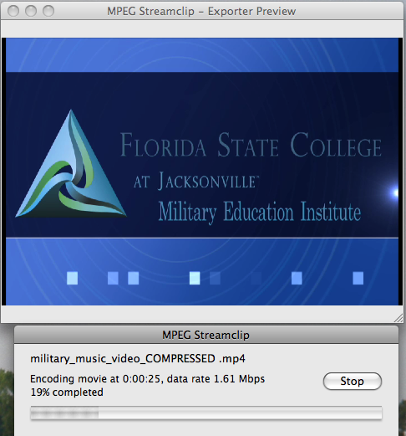

Congratulations! Your compressed video can be found in the location you chose to save it. In this example the size has been reduced from 6.83 GB to 25.2 MB