Request Ensemble access by contacting Michelle Nifong at manifong@fscj.edu
Once you have been set up in the system, log into Ensemble at: http://mediaworks.fscj.edu with your domain username and password
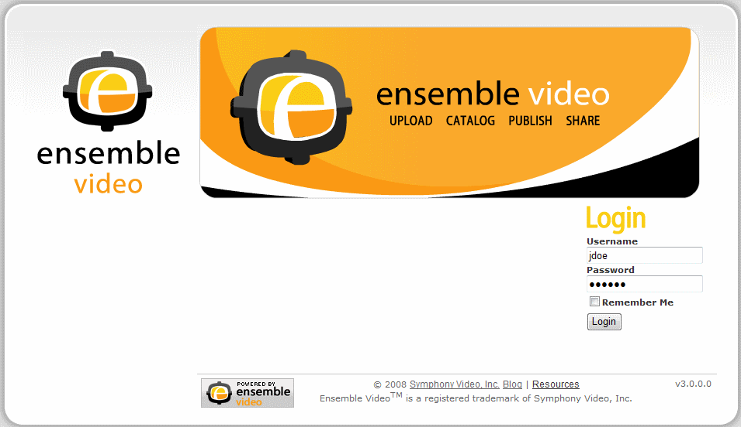

To create a new video entry, click the button. This will open a wizard that will take you through a series of forms to create and describe your content. There are five main forms in the wizard:
- Description – Where you enter description information, then choose Save & Continue
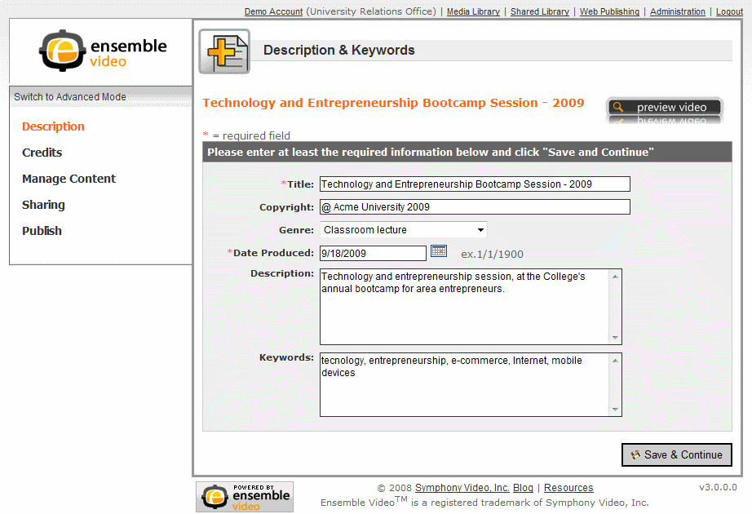
- Credits (optional) – Where you add credits (Narrator, Director, Producer, etc.), then choose Continue
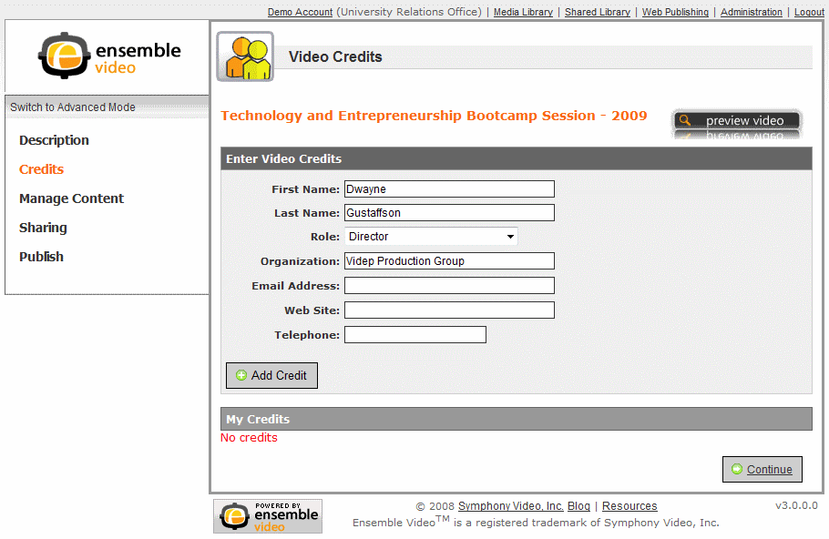

- Manage Content – A set of forms where you can upload/manage audio-video, closed captions, images, attachments, and Web links. This form is different from the other forms in the Wizard since it has a drop down that lets you navigate to sub-forms for different content types.
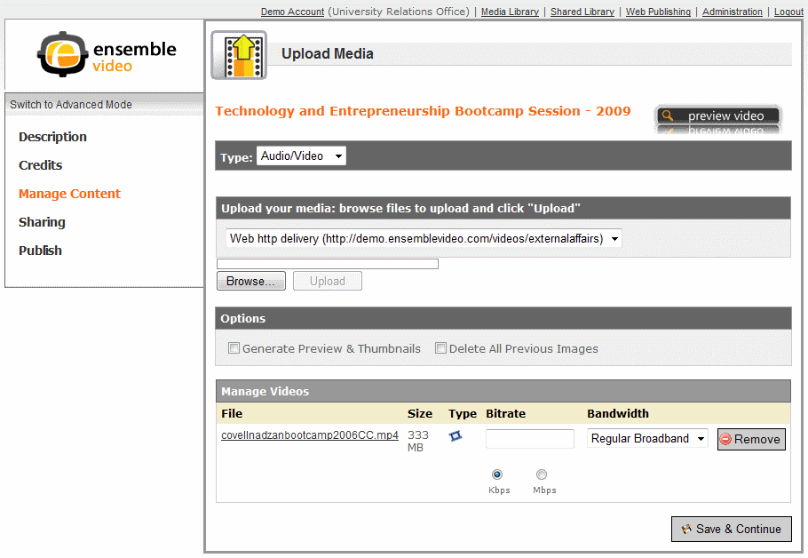
3a. Audio-Video – When you first navigate to the Manage Content form, you can upload Audio-Video file(s). This is the default sub-form, and very often you will just upload your video and then click 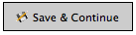 to navigate to the Sharing form, without accessing other Manage Content sub-forms.
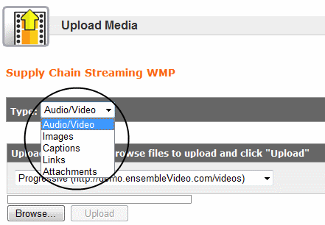

3b. Images – This sub-form is for selecting thumbnail and preview animation images for each video in your library or to upload and publish an image gallery. When you upload a video file, a series of still images are automatically extracted. You can select the preview animation and thumbnail frames from the extracted images. Just check the boxes in the “Preview” and “Thumb” columns. For “Previews”, you can select multiple images. For “Thumbs”, select a single image. To delete one or more images, first select the check-box in the right-most column of the Manage Images area adjacent to the image(s) you want to remove. You can select all images by clicking on the check-box to the left of the button at the top of the Manage Images section of the form. Then click on the button to remove the selected images.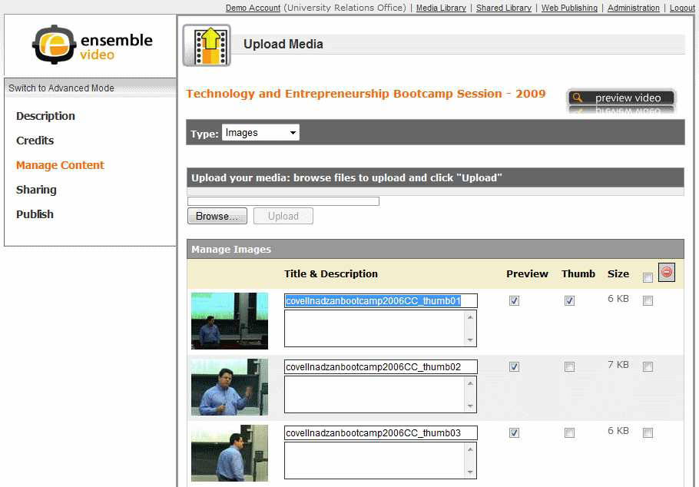
Image Gallery – To create an image gallery just go to Manage Content, use the dropdown to navigate to the Images sub-form, and upload the images for your gallery. In the image sub-form, you can click on an individual image to launch an image viewer. Hover over the right hand portion of the image and click “Next” to browse to the next image in the gallery.
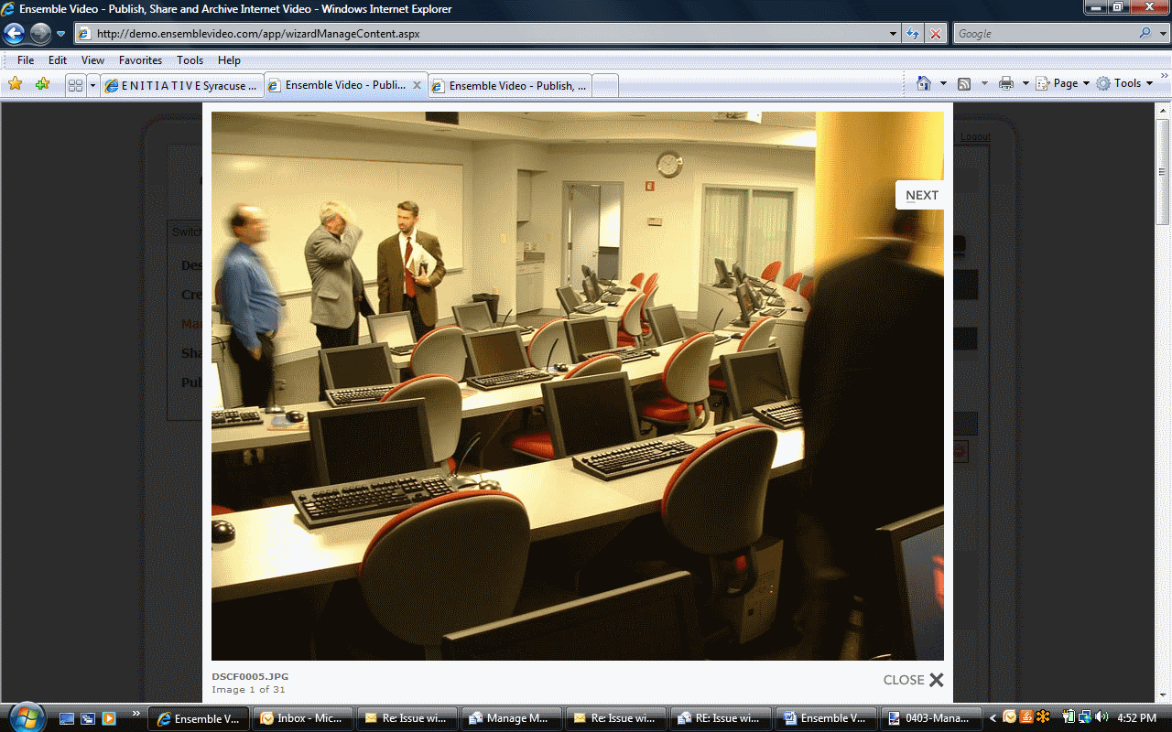
You may want to edit the Title and Description of the images in your gallery. This information will be used in the image navigator your viewers will see when they view the image gallery using Quick Publish or the Ensemble Video HTML Plugin.
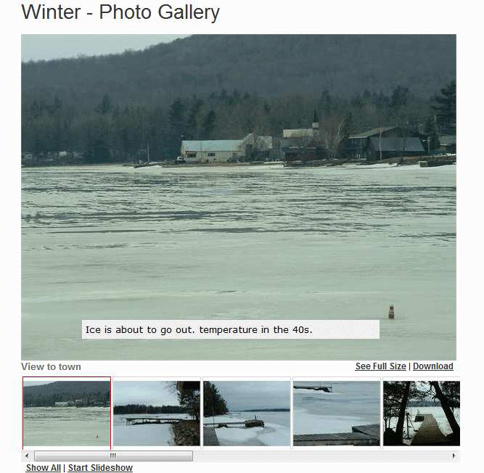
3c. Captions – Here you can upload a W3C DFXP Timed Text caption file. The captions will automatically display with video content that is played via the Flash-based player. Just click the button to navigate to your file, then .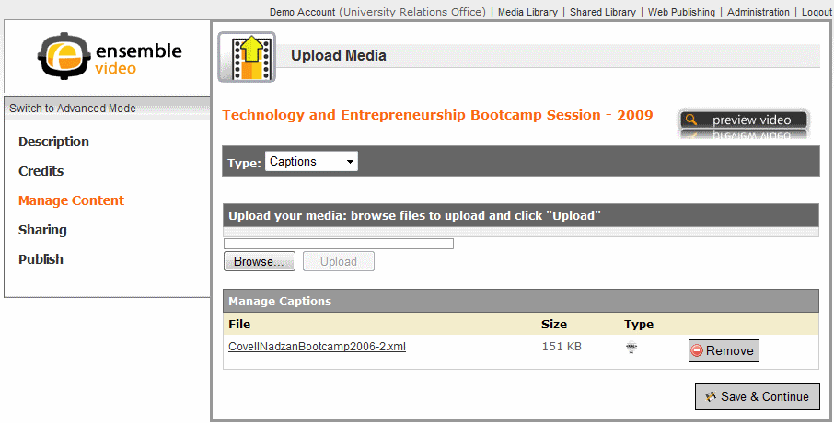
3d. Links – In the Links sub-form, you can add Web site links you would like to appear on video detail pages for your viewers. Enter Title, URL, and Description (optional) and click on 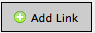. You can add as many links as you’d like. You can remove links from the list with the button.
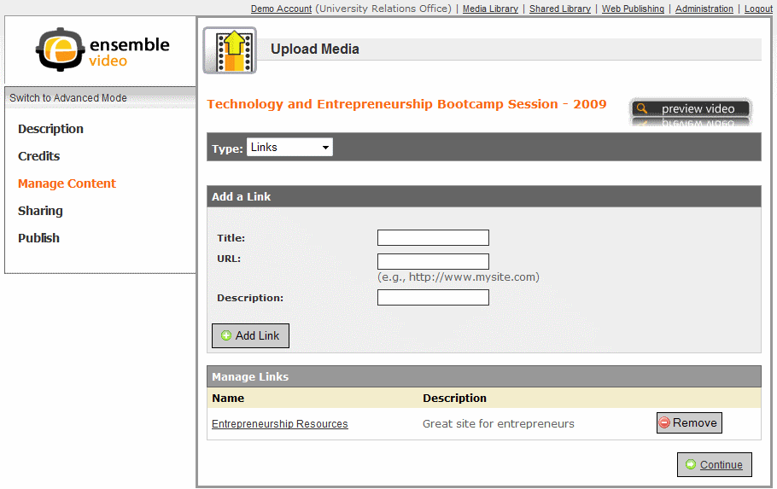

3e. Attachments – In this Manage Content sub-form, you can upload associated files that will be accessible with your published video. The form uses the same controls as documented previously for uploading, documenting, and removing audio-video and images.
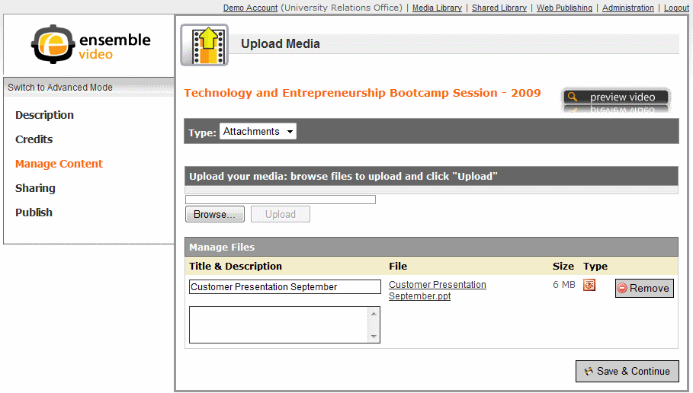

- Sharing – The Sharing form lets you specify the external Web destinations
where you want to share your video so it’s available to your viewers. Simply check those Web sites and corresponding content categories where you want your content to be displayed. Remember that you must choose at least one category per Web site to publish your video at that Web destination. Click to move forward to the last step.
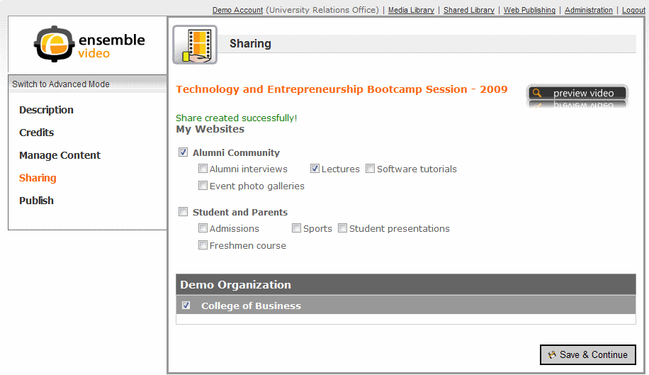

- Publish – To make your content live for internal and external viewers, simply
check the Publish Content check-box, then click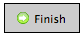 and your library entry will be live on all Web destinations selected in the sharing form.
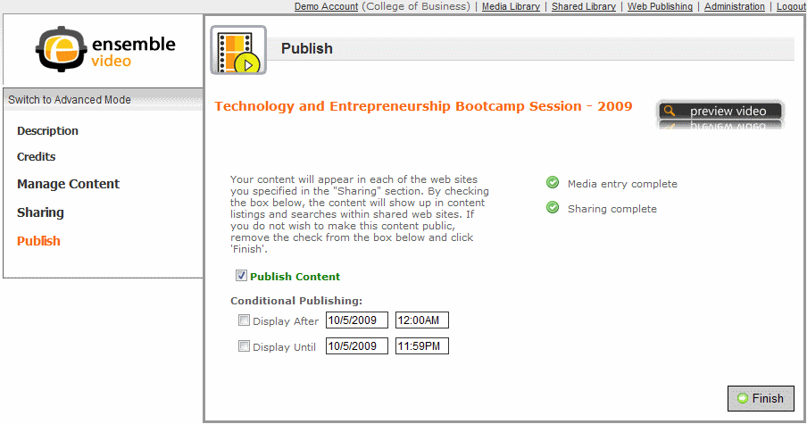

Conditional Publishing allows you to specify a date/time for when the item is auto-published and/or automatically un-published. Just click the check-box for “Display Until” and/or “Display After” and adjust the date/time fields to suit your needs.

